**Working with Data Tables/Data Types/ Data Classes/Data Storage:**

* **A Data Type is like a Table which has Data Storage.**
* **Data Types can be created using “Data Types” explorer.**
* **All the Data Classes are Concrete - Doesn't belongs to Class group**
* **Does not Belongs to a Class Group : - A Class which is not in the Inheritance path of Class Group. This class is a Global class, can be accessed anywhere from any class**

**When we create a Data Type and Define the Storage PRPC creates below Rules.**

1. **Data Class will get created. (Make sure this class should be created under Data Layer).**
2. **Properties ( Manually Give Property Names)**
3. **Database Table mapping rule will be created/Data Class**
4. **A Physical (Dedicated) Table will get created. ( PR Table)**
5. **Report Definition**
6. **Data Page ( 3 Types of Data Page Rule)**

**Data Type Layers:**

**1. Implementation/Division Data Layer (Ex: - ALFA-ALFAAUTO-Data)**

**2. Organization Data Layer (Ex: ALFA-Data) – Best Practice**

**-------------------------------**

**Req: Create a New data type: StatesTable with Column Names State Name & State Code under Organization data Layer & Set State Code as Class Key.**

**Create table form Data Type Explorer**

**GO to Data Types Explorer:**

**Click on Add Data Type**

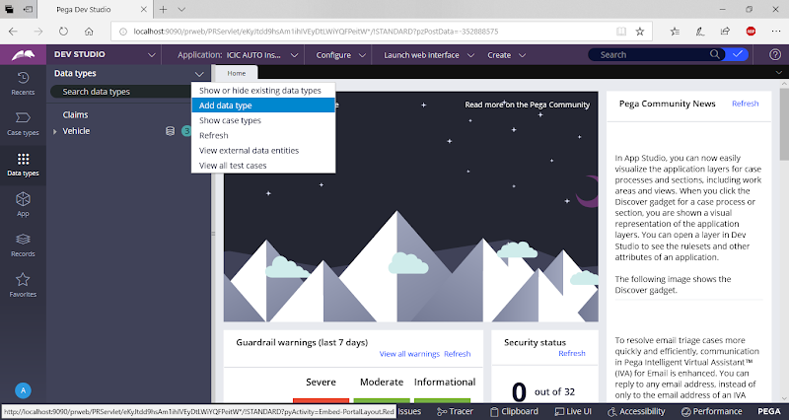

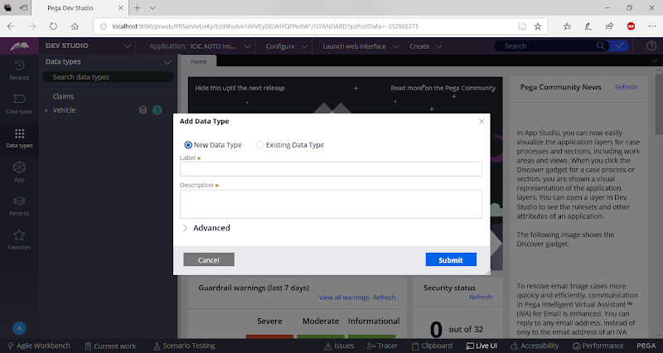

**Add Data Type/Data Table Name**

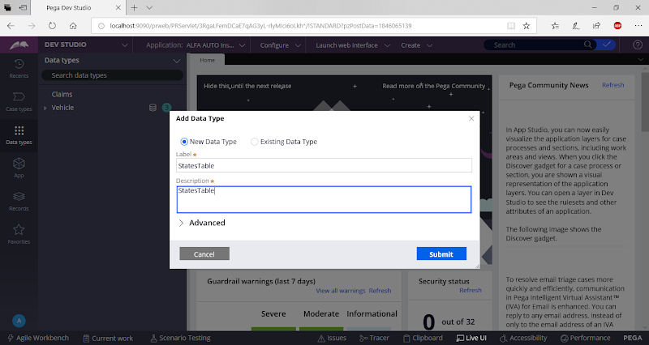

**Expand Advanced Option & Change Class Name**

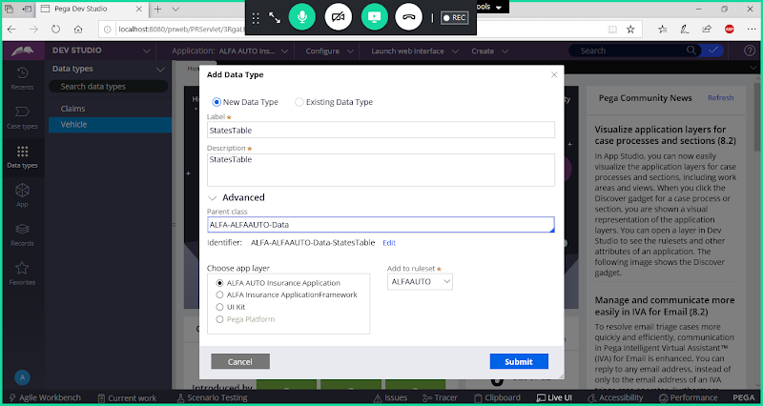

**Update Parent Class to Organization data Layer( OrgName-Data)**

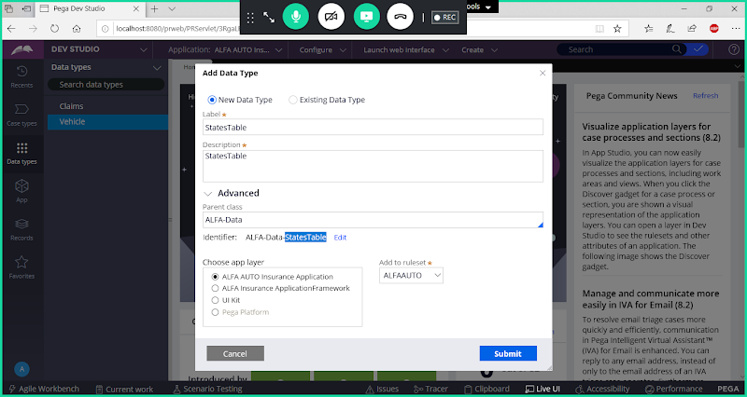

**Submit**

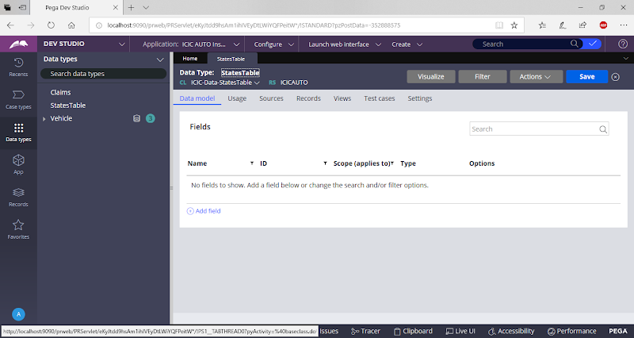

**Add New Fields**

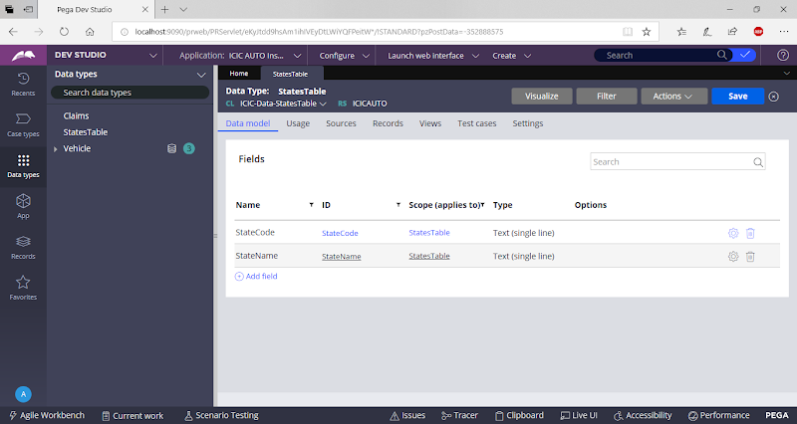

**Set Class Key from Records tab/Source Tab:**

**Go to Records Tab:**

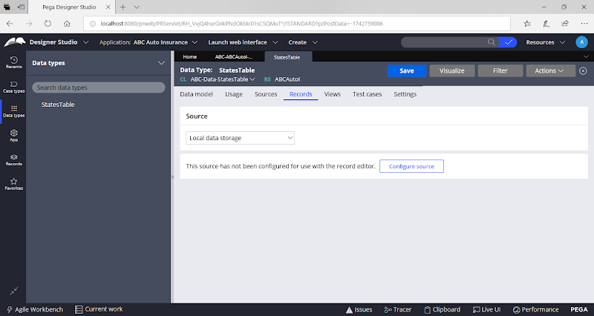

**Click on Configure Source**

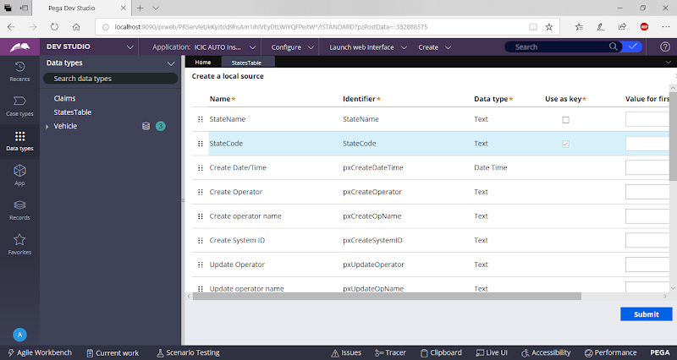

**Select State Code as Class Key ( Enable Check box for State Code)**

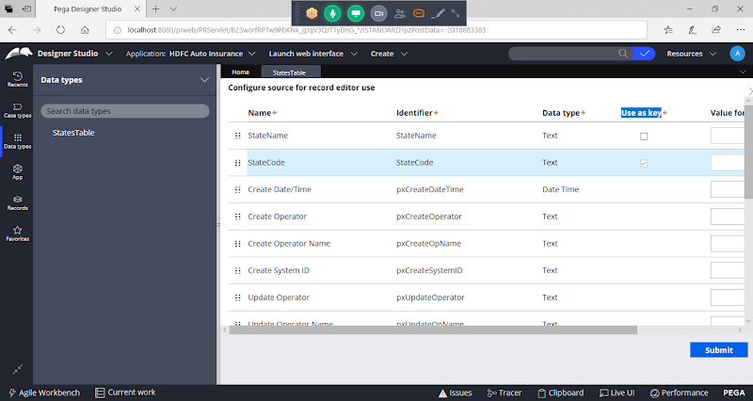

**Submit**

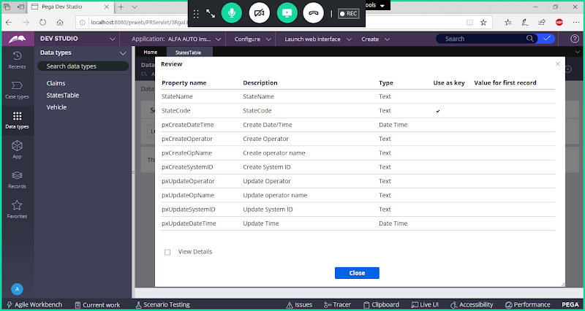

**Select View Details Check box:**

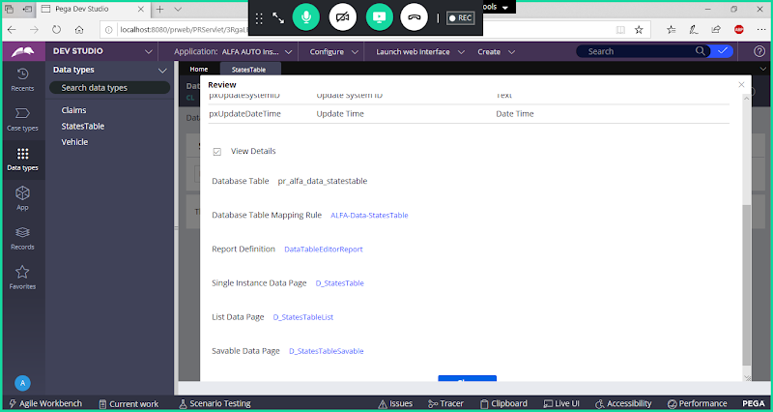

**Click on Close**

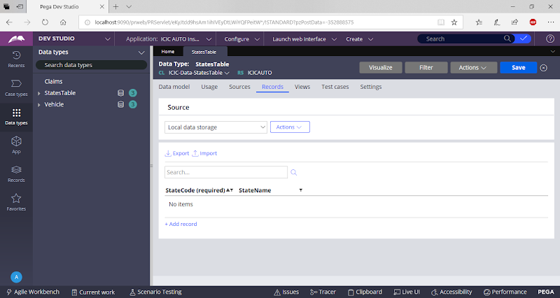

**Manually Insert Records for StateCode & StateName**

